**Nexus**

**Home**

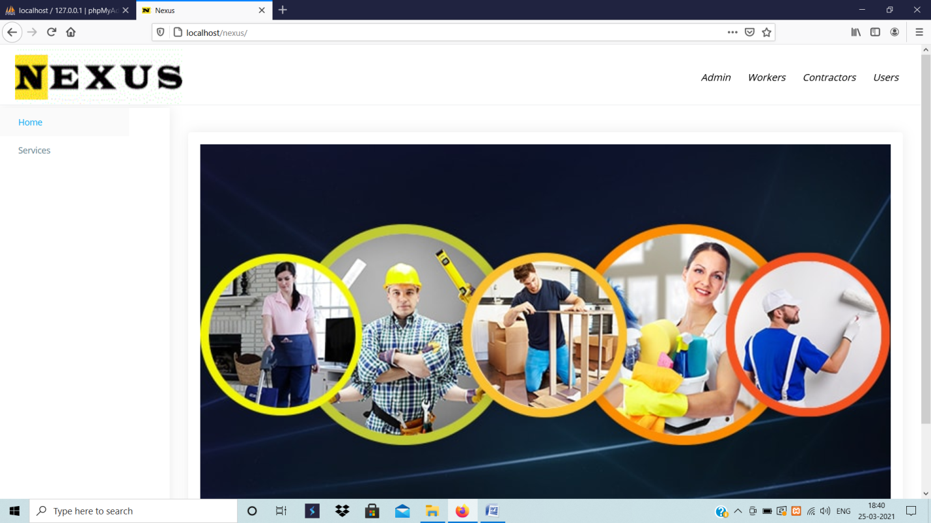

**Services**

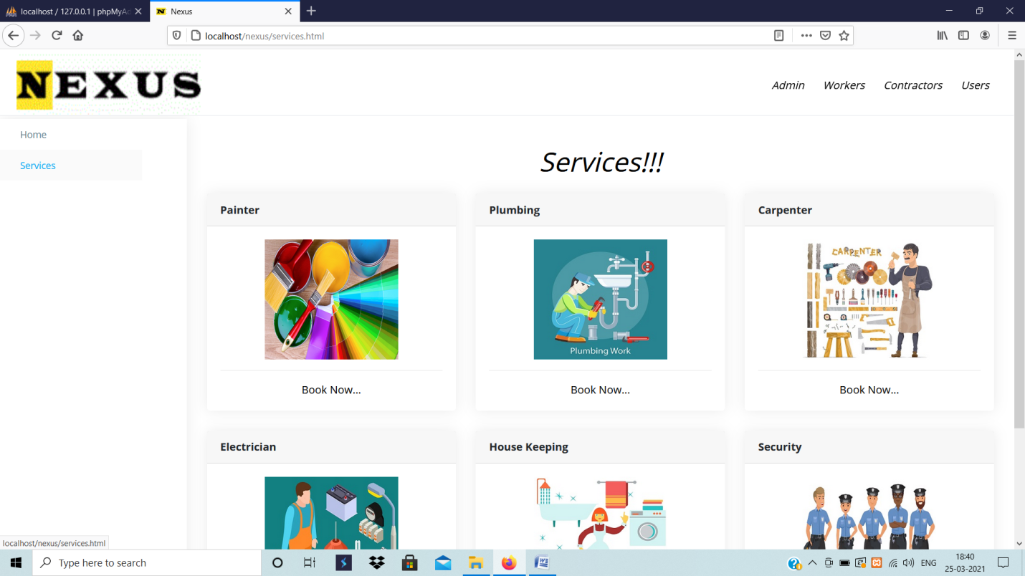

**Admin Login**

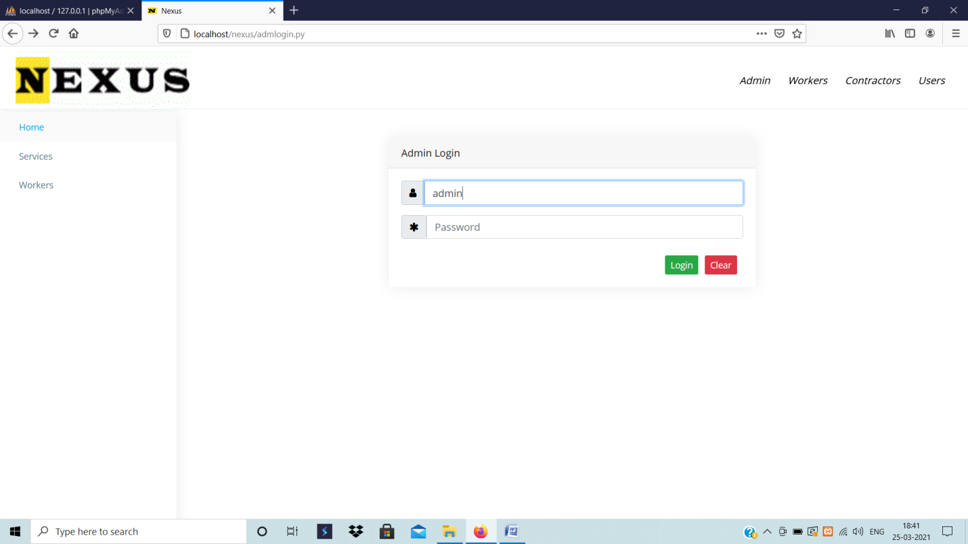

**Admin Dashboard**

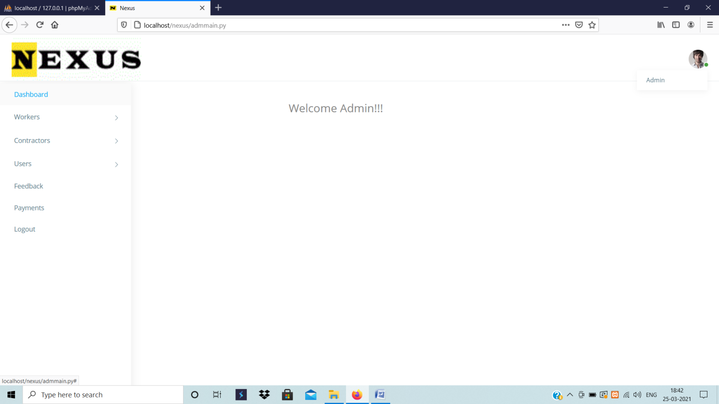

**Admin Accept New Workers**

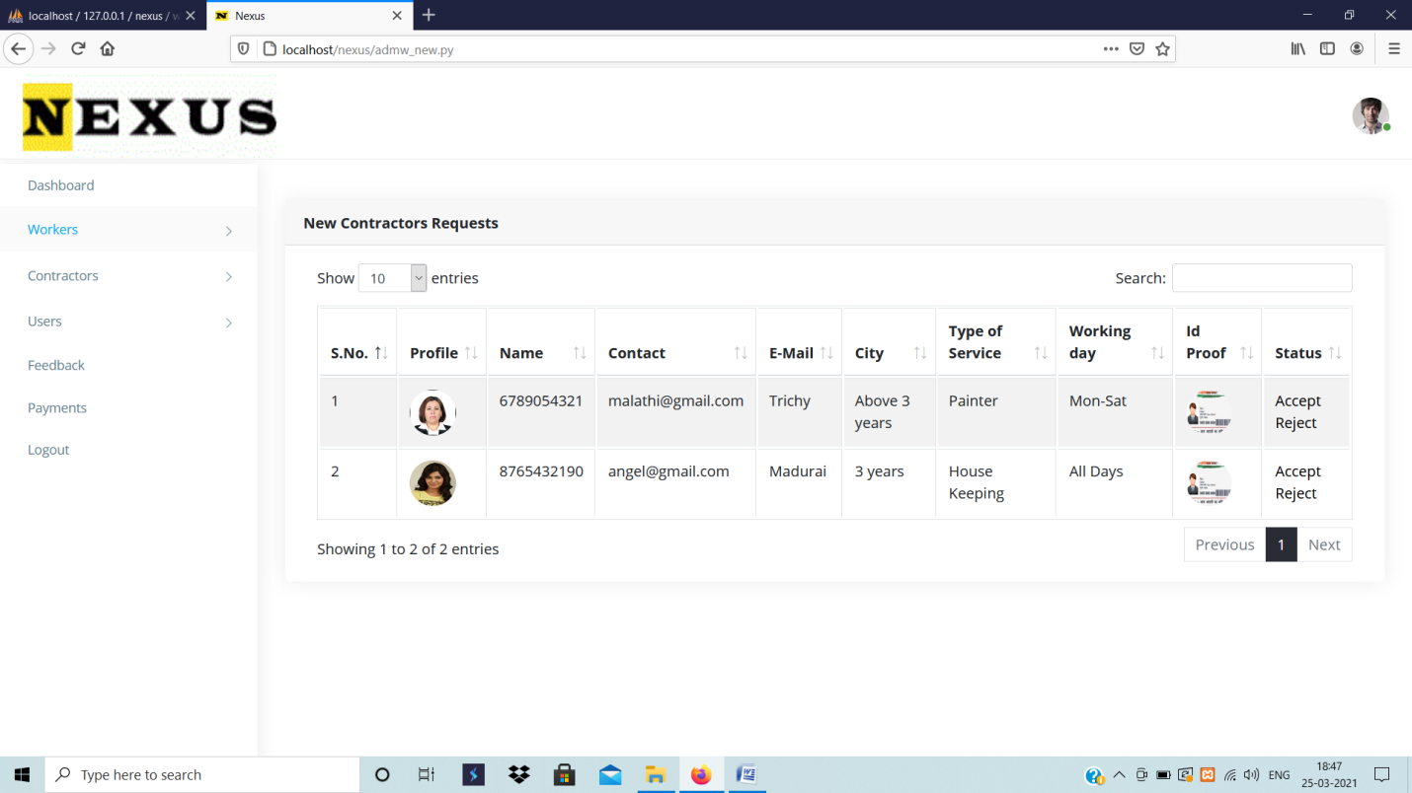

**Workers Registration**

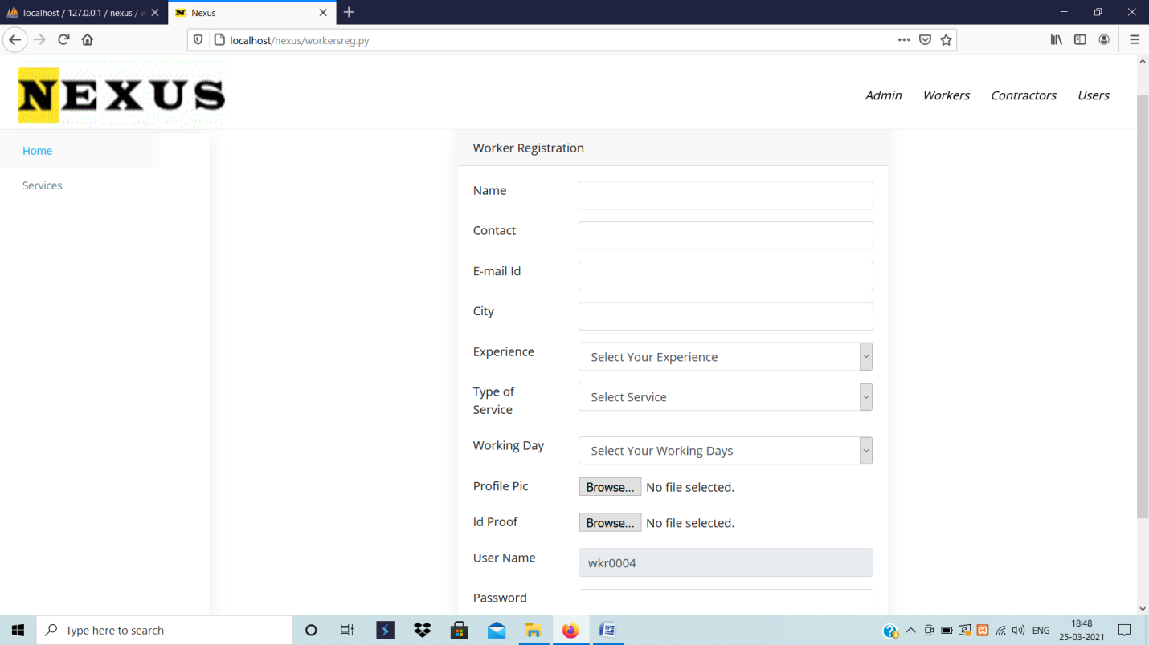

**Workers Login**

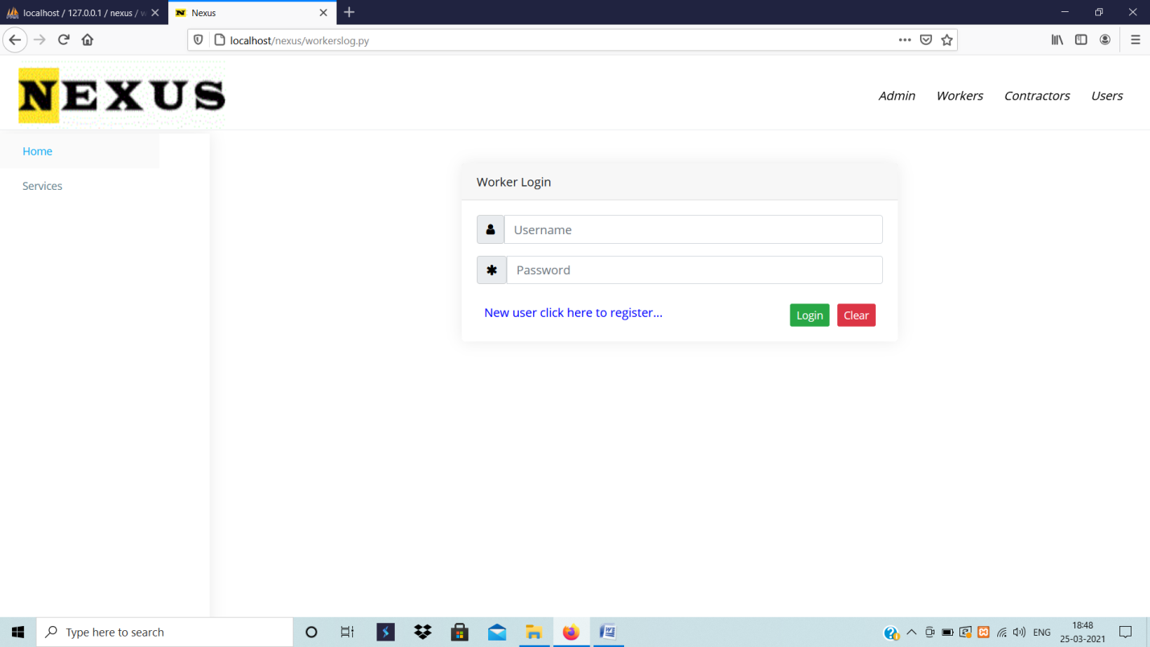

**Workers Dashboard**

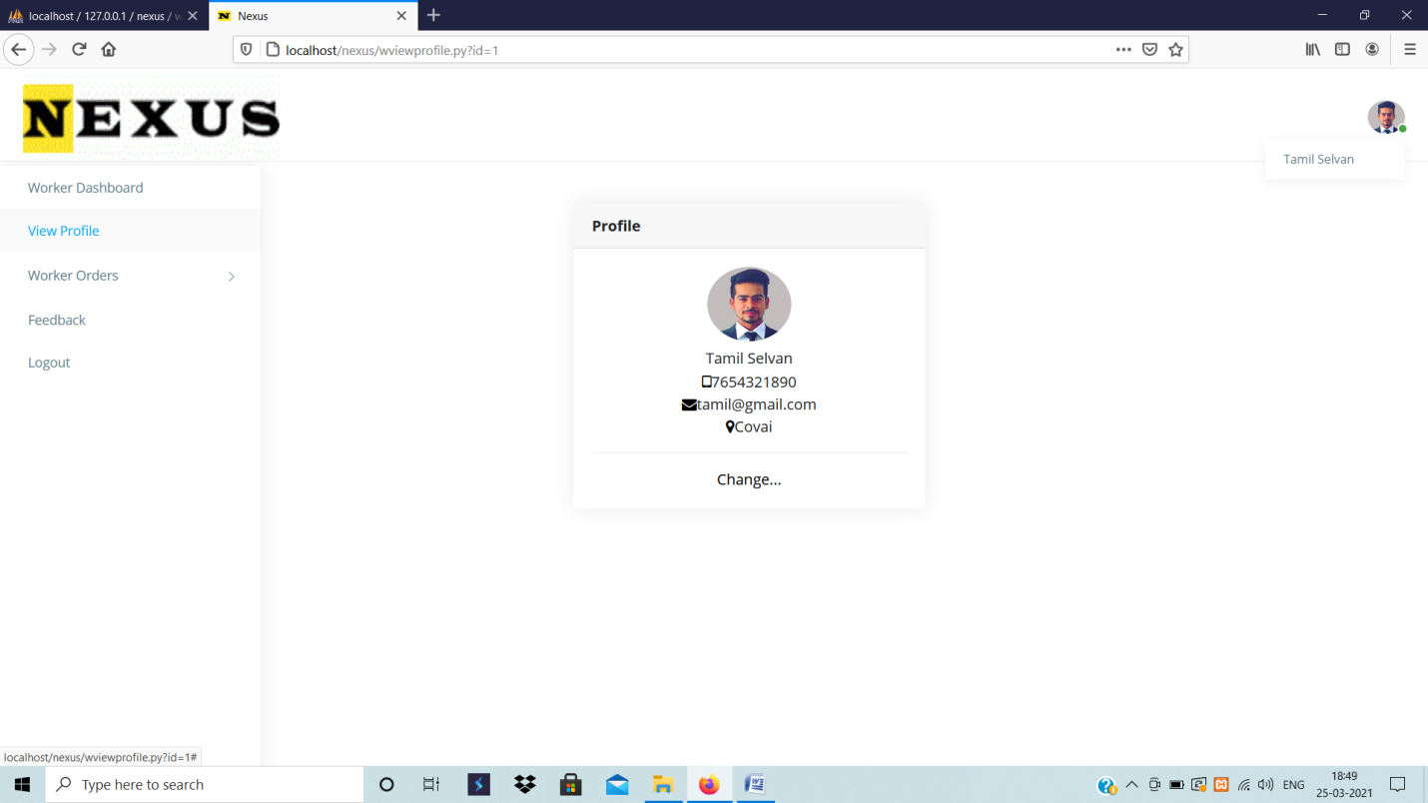

**Contractor Dashboard**

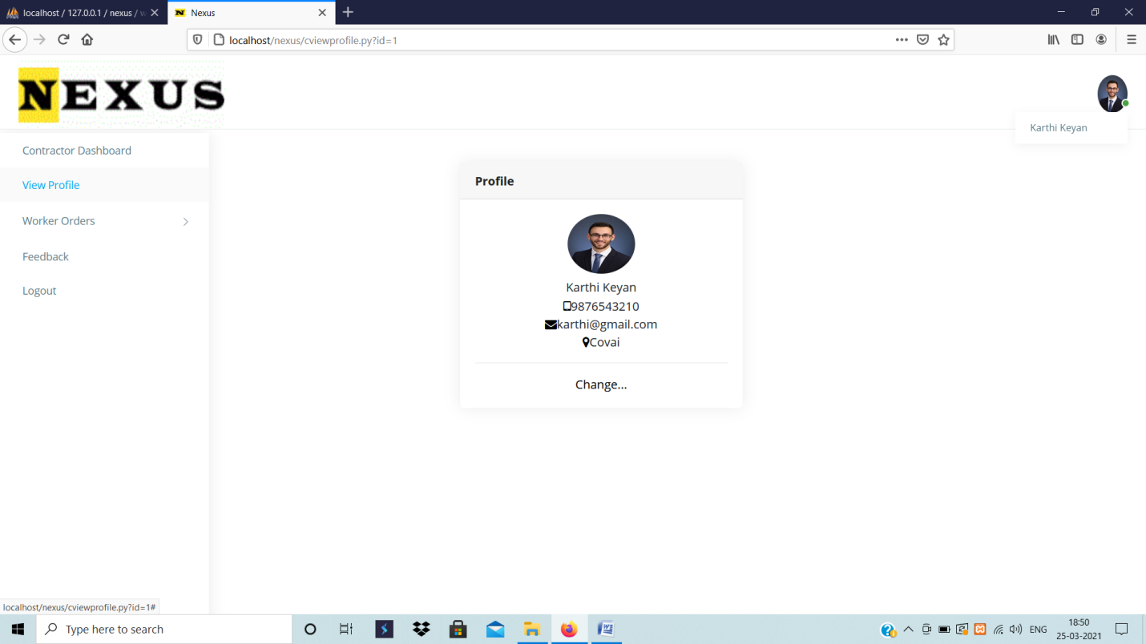

**User Work Request**

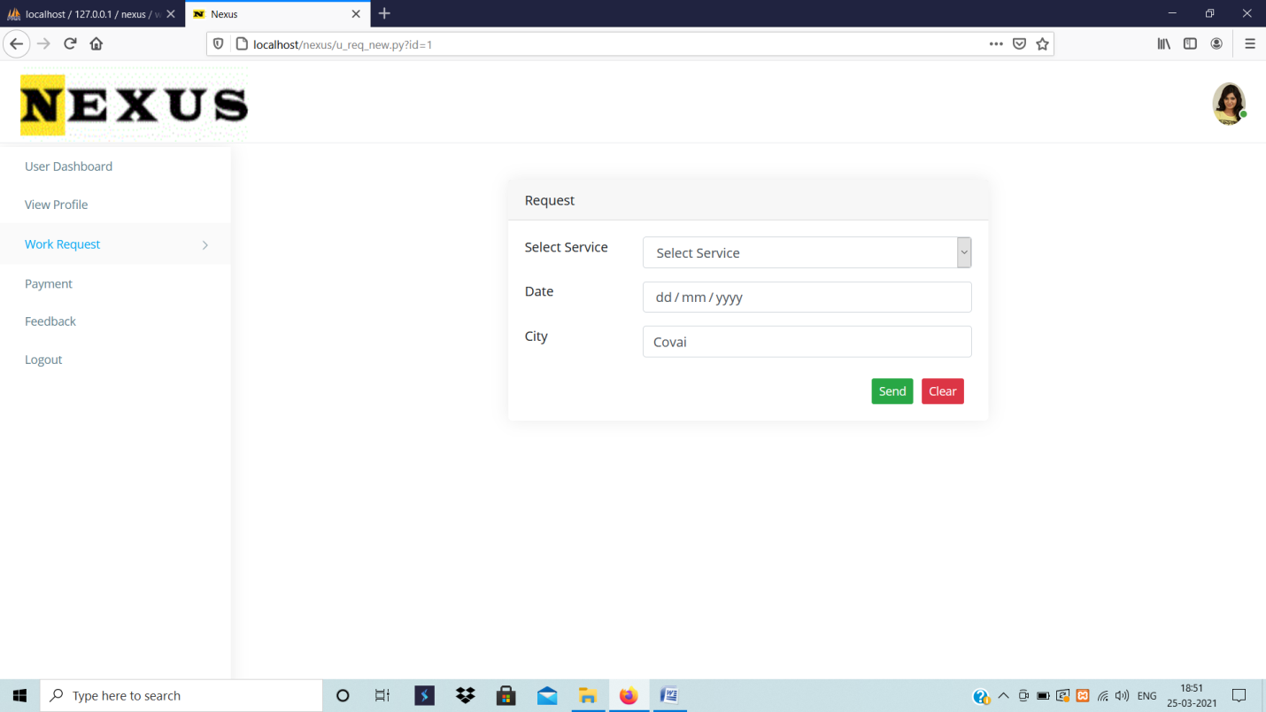

**Table Description**

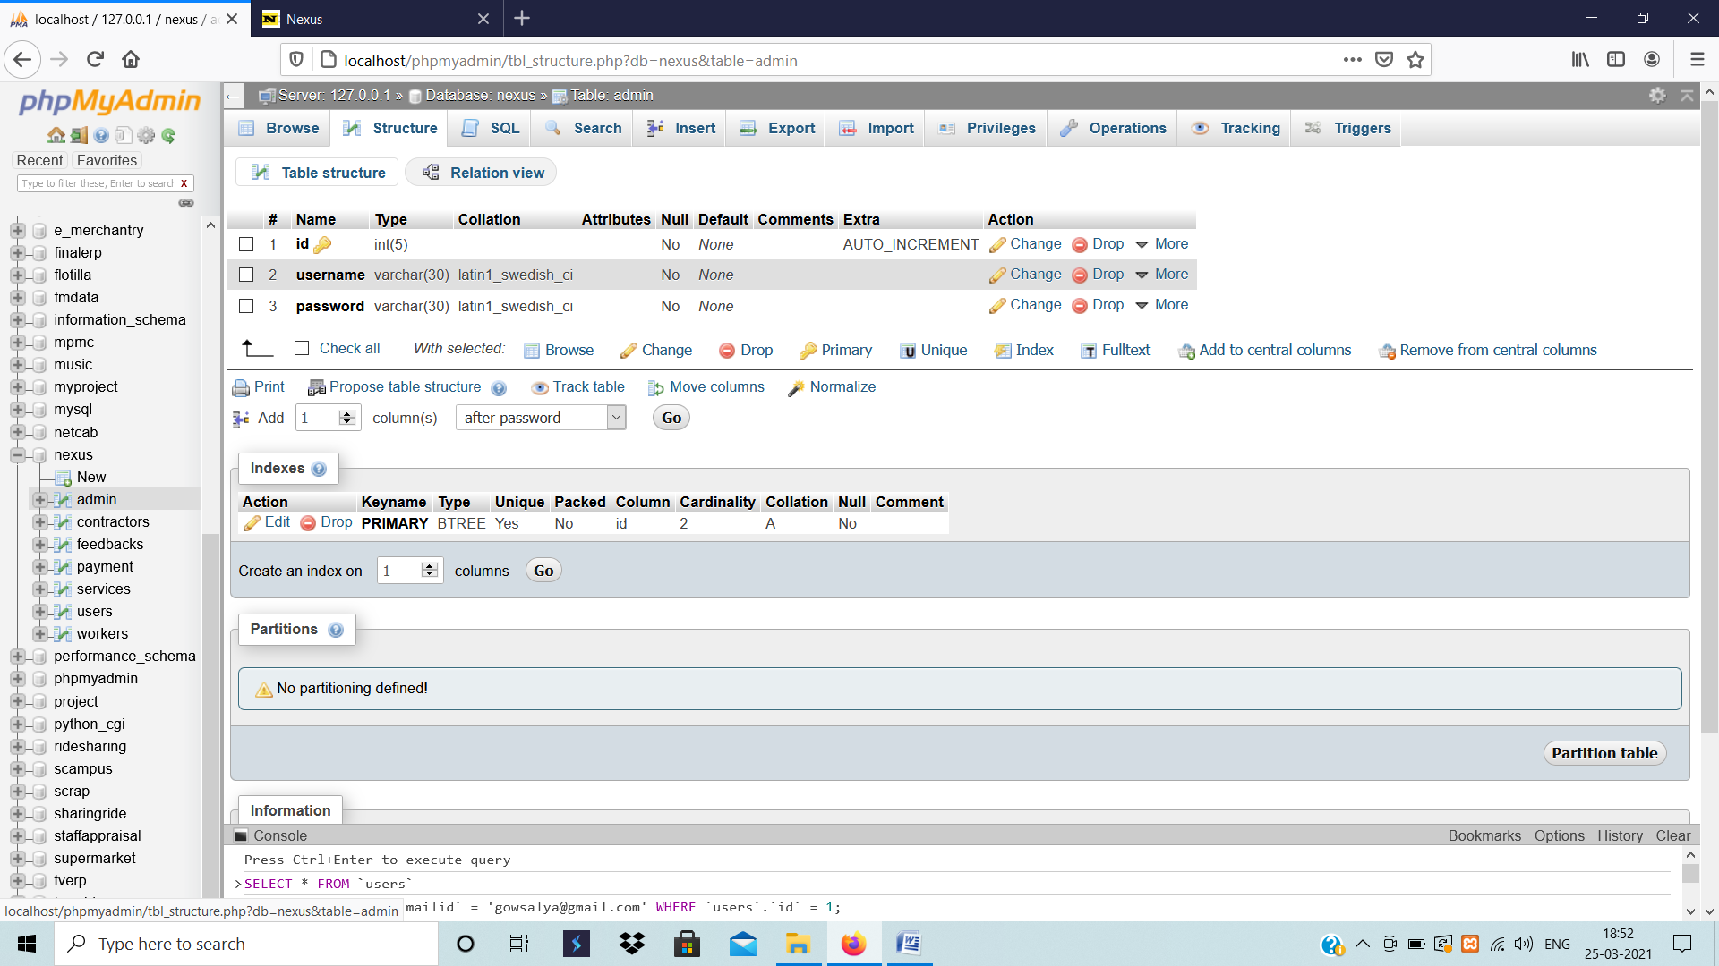

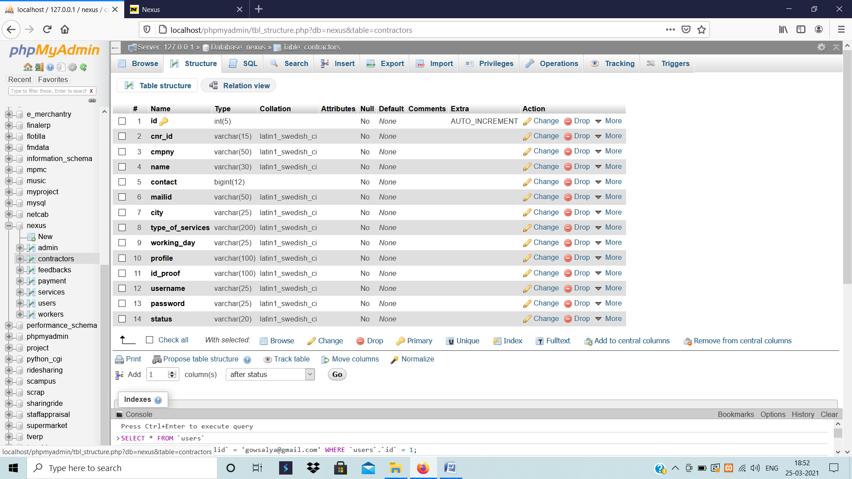

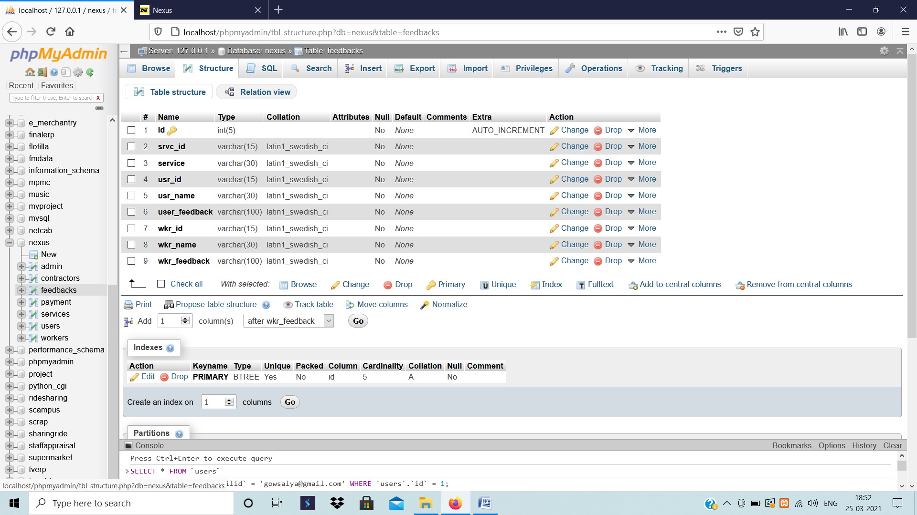

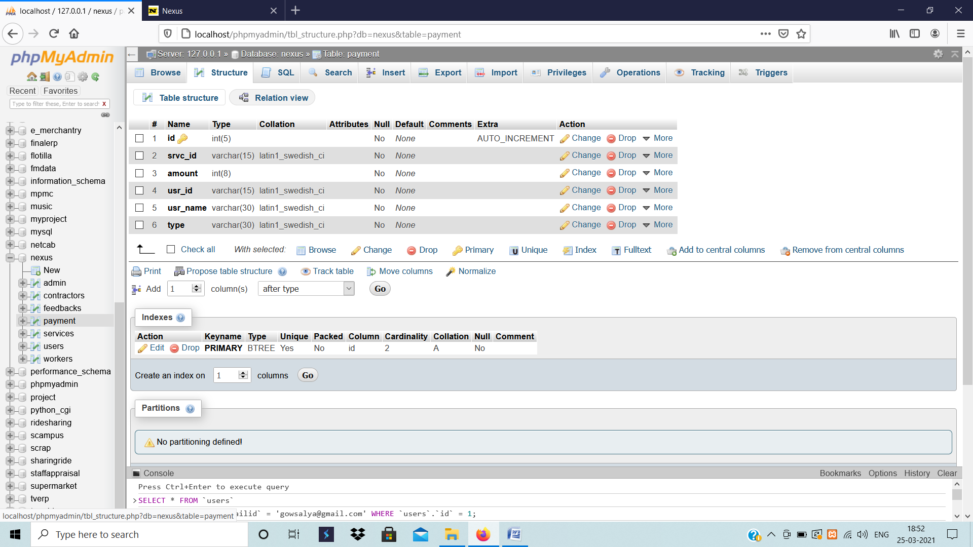

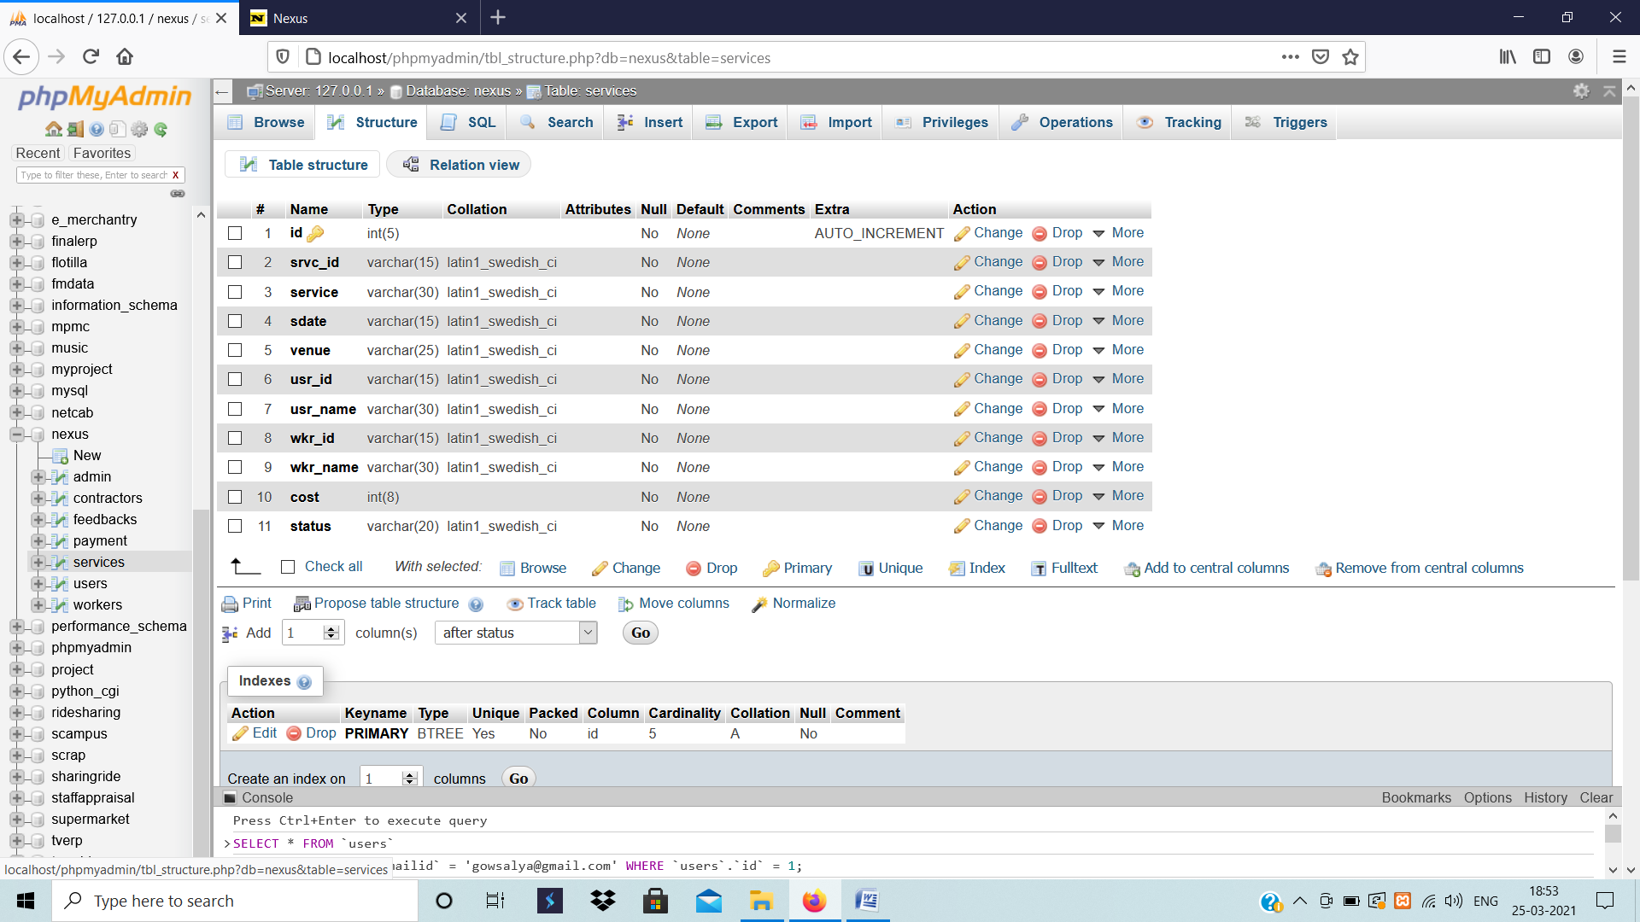

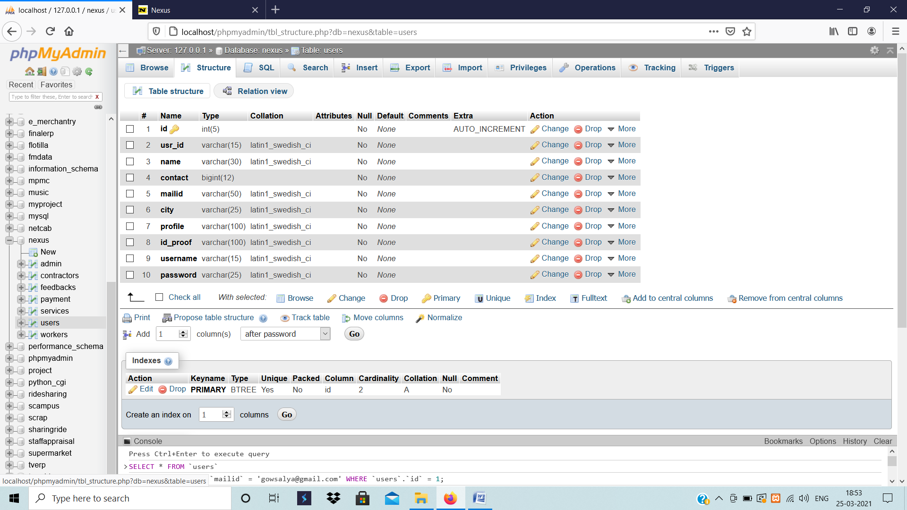

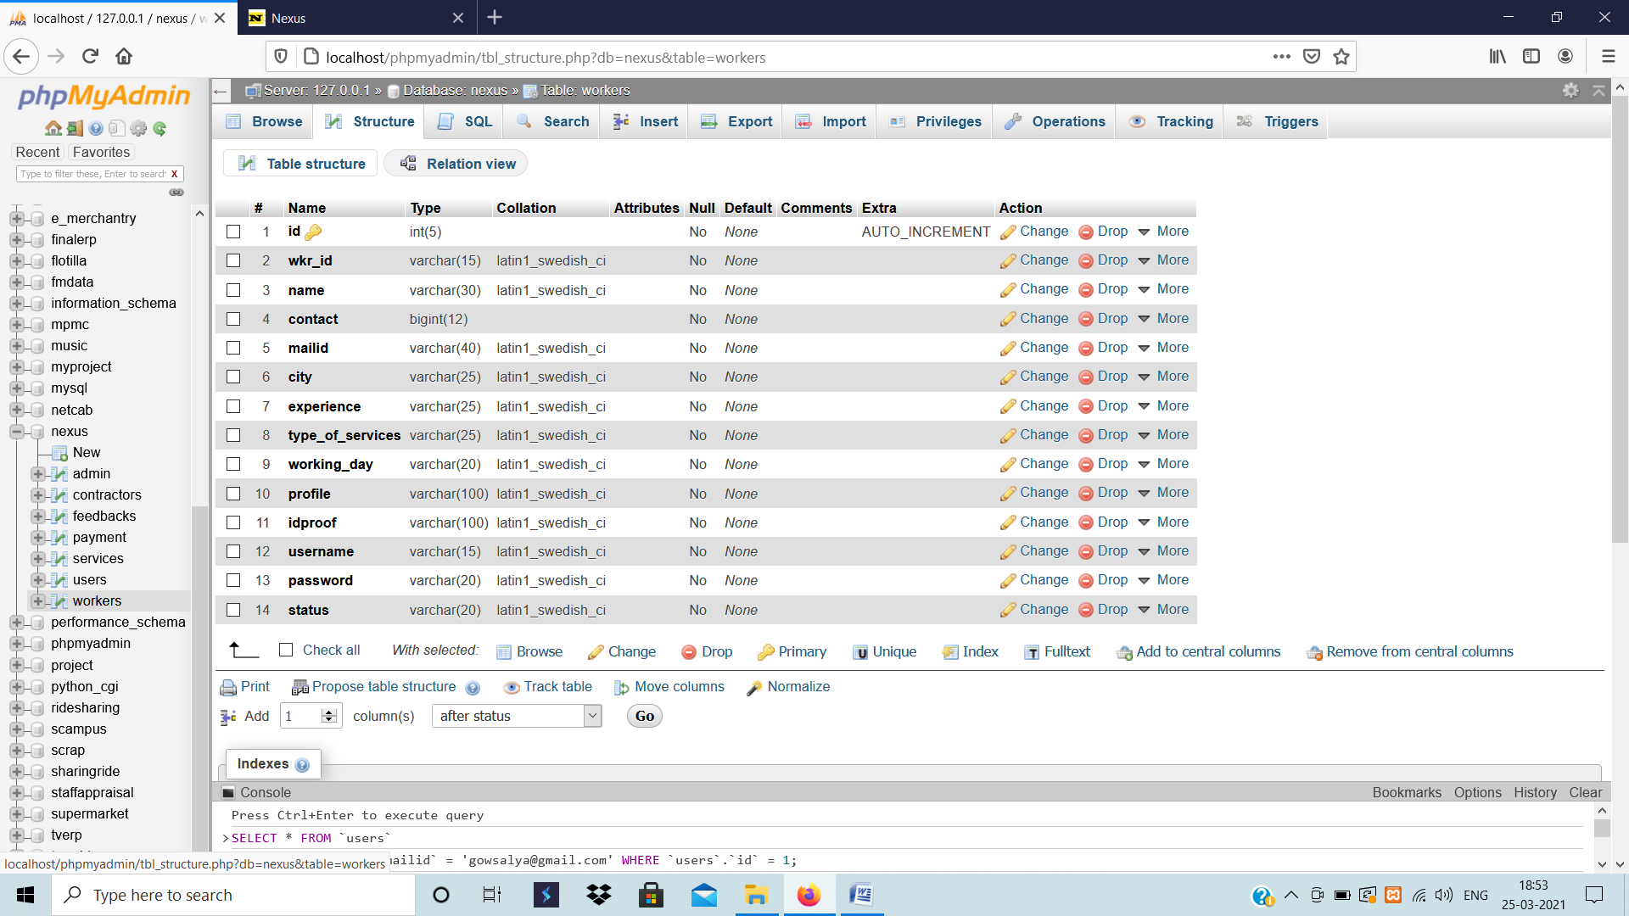

**Code**

**Admin_uview.py**

#!C:/Users/Admin/AppData/Local/programs/python/python37-32/python.exe

print("content-type:text/html \r\n\r\n")

import cgi

import pymysql,cgitb;cgitb.enable()

conn=pymysql.connect("localhost","root","","nexus")

cur=conn.cursor()

q="""select * from users"""

cur.execute(q)

r=cur.fetchall()

cnt=0

print("""

<!doctype html>

<html>

<head>

<title>Nexus</title>

<link rel="shortcut icon" href="images/n.png">

<link rel="stylesheet" href="https://cdn.jsdelivr.net/npm/normalize.css@8.0.0/normalize.min.css">

<link rel="stylesheet" href="https://cdn.jsdelivr.net/npm/bootstrap@4.1.3/dist/css/bootstrap.min.css">

<link rel="stylesheet" href="https://cdn.jsdelivr.net/npm/font-awesome@4.7.0/css/font-awesome.min.css">

<link rel="stylesheet" href="https://cdn.jsdelivr.net/gh/lykmapipo/themify-icons@0.1.2/css/themify-icons.css">

<link rel="stylesheet" href="https://cdn.jsdelivr.net/npm/pixeden-stroke-7-icon@1.2.3/pe-icon-7-stroke/dist/pe-icon-7-stroke.min.css">

<link rel="stylesheet" href="https://cdnjs.cloudflare.com/ajax/libs/flag-icon-css/3.2.0/css/flag-icon.min.css">

<link rel="stylesheet" href="assets/css/cs-skin-elastic.css">

<link rel="stylesheet" href="assets/css/lib/datatable/dataTables.bootstrap.min.css">

<link rel="stylesheet" href="assets/css/style.css">

<link href='https://fonts.googleapis.com/css?family=Open+Sans:400,600,700,800' rel='stylesheet' type='text/css'>

<style>

a,i{

color:#000;}

</style>

</head>

<body>

<aside id="left-panel" class="left-panel" style="margin-top:50px;">

<nav class="navbar navbar-expand-sm navbar-default">

<div id="main-menu" class="main-menu collapse navbar-collapse">

<ul class="nav navbar-nav">

<li>

<a href="admmain.py">Dashboard</a>

</li>

<li class="menu-item-has-children dropdown">

<a href="#" class="dropdown-toggle" data-toggle="dropdown" aria-haspopup="true" aria-expanded="false"> Workers</a>

<ul class="sub-menu children dropdown-menu">

<li><a href="admw_new.py">New</a></li>

<li><a href="admw_exis.py">Existing</a></li>

</ul>

</li>

<li class="menu-item-has-children dropdown">

<a href="#" class="dropdown-toggle" data-toggle="dropdown" aria-haspopup="true" aria-expanded="false"> Contractors</a>

<ul class="sub-menu children dropdown-menu">

<li><a href="admc_new.py">New</a></li>

<li><a href="admc_exis.py">Existing</a></li>

</ul>

</li>

<li class="menu-item-has-children dropdown active">

<a href="#" class="dropdown-toggle" data-toggle="dropdown" aria-haspopup="true" aria-expanded="false"> Users</a>

<ul class="sub-menu children dropdown-menu">

<li><a href="admu_new_req.py">New Requests</a></li>

<li><a href="admu_exis_orders.py">Existing Orders</a></li>

<li><a href="admu_view.py">Users</a></li>

</ul>

</li>

<li>

<a href="adm_feedback.py">Feedback</a>

</li>

<li>

<a href="adm_payments.py">Payments</a>

</li>

<li>

<a href="index.html">Logout</a>

</li>

</ul>

</div><!-- /.navbar-collapse -->

</nav>

</aside>

<!-- Right Panel -->

<div id="right-panel" class="right-panel">

<!-- Header-->

<header id="header" class="header" style="height:100px;padding:25px;"/>

<div class="top-left">

<div class="navbar-header" style="width:300px;">

<a class="navbar" href="./"><img src="images/nlogo.png" width="400" height="100" style="margin-top:-27px;"alt="Logo"></a>

</div>

<!-- <a ><i style="font-size:25pt;">Nexus</i></a> -->

</div>

<div class="top-right">

<div class="header-menu">

<div class="header-left">

<div class="user-area dropdown float-right">

<a href="#" class="dropdown-toggle active" data-toggle="dropdown" aria-haspopup="true" aria-expanded="false">

<img class="user-avatar rounded-circle" src="images/admin.jpg" alt="User Avatar">

</a>

<div class="user-menu dropdown-menu">

<a class="nav-link" href="#"><i class="fa fa- user"></i>Admin</a>

</div>

</div>

</div>

</div>

</div>

</header>

<!-- /#header -->

<div class="content" style="margin-top:60px;">

<div class="animated fadeIn">

<div class="row">

<div class="col-md-12">

<div class="card">

<div class="card-header">

<strong class="card-title">New Contractors Requests</strong>

</div>

<div class="card-body">

<table id="bootstrap-data-table" class="table table-striped table-bordered">

<thead>

<tr>

<th>S.No.</th>

<th>Profile</th>

<th>Name</th>

<th>Contact</th>

<th>E-Mail</th>

<th>City</th>

<th>Id Proof</th>

</tr>

</thead>

<tbody>""")

for i in r:

cnt=cnt+1

fn="files/"+i[6]

fn1="files/"+i[7]

print("""

<tr>

<td>%s</td>

<td class="avatar">

<div class="round-img">

<a href="%s" target="blank"><img class="rounded-circle" src="%s" alt="" width="50" height="50"></a>

</div>

</td>

<td>%s</td>

<td>%s</td>

<td>%s</td>

<td>%s</td>

<td class="avatar">

<div class="round-img">

<a href="%s" target="blank"><img class="rounded-circle" src="%s" alt=""width="50" height="50"></a>

</div>

</td>

</tr>"""%(cnt,fn,fn,i[2],i[3],i[4],i[5],fn1,fn1))

print("""

</tbody>

</table>

</div>

</div>

</div>

</div>

</div><!-- .animated -->

</div><!-- .content -->

<script src="https://cdn.jsdelivr.net/npm/jquery@2.2.4/dist/jquery.min.js"></script>

<script src="https://cdn.jsdelivr.net/npm/popper.js@1.14.4/dist/umd/popper.min.js"></script>

<script src="https://cdn.jsdelivr.net/npm/bootstrap@4.1.3/dist/js/bootstrap.min.js"></script>

<script src="https://cdn.jsdelivr.net/npm/jquery-match-height@0.7.2/dist/jquery.matchHeight.min.js"></script>

<script src="assets/js/main.js"></script>

<script src="https://cdn.jsdelivr.net/npm/bootstrap@4.1.3/dist/js/bootstrap.min.js"></script>

<script src="assets/js/lib/data-table/datatables.min.js"></script>

<script src="assets/js/lib/data-table/dataTables.bootstrap.min.js"></script>

<script src="assets/js/lib/data-table/dataTables.buttons.min.js"></script>

<script src="assets/js/lib/data-table/buttons.bootstrap.min.js"></script>

<script src="assets/js/lib/data-table/jszip.min.js"></script>

<script src="assets/js/lib/data-table/vfs_fonts.js"></script>

<script src="assets/js/lib/data-table/buttons.html5.min.js"></script>

<script src="assets/js/lib/data-table/buttons.print.min.js"></script>

<script src="assets/js/lib/data-table/buttons.colVis.min.js"></script>

<script src="assets/js/init/datatables-init.js"></script>

<script type="text/javascript">

$(document).ready(function() {

$('#bootstrap-data-table-export').DataTable();

} );

</script>

</body>

</html>

""")